RAYHAN RAMANDA-2501982582-L1AC

Technical Report

**SPECIFICATION**

Objective: To help visually impaired persons, I create Text to Speech application based on Python Language

Description: This application converts text to speech. Very simple but powerful utilities to impaired vision as long he/she still having functional hearing

**DESIGN**

Files Involved: TTS.py, modules.py, speech.mp3 (to be overwritten each new input downloaded)

1. TTS.py

Purpose: to hold all functional codes for converting the input to audio output, also housing scripts for UI window design, so no need manually inputting on the script.

Components (shown below):



This line for importing the modules from TTS.py

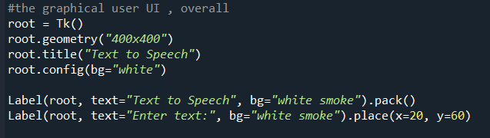

This line is for build the dimension of app window, window title and the background color. Also

The Label is for putting text inside the windows

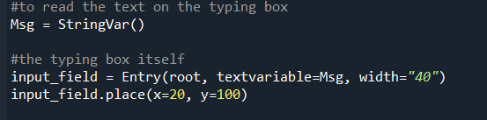

This snippet of codes is to convert the input into string and input_field is for the input (text box, I use this etymology from C#), and read it as msg. Also the input_field already have Entry variable , so the next codes can read and transform what inside the text box is

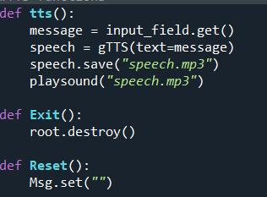

There are 3 definitions, having different purpose and property. The def TTS() is to convert the text box content to become hearable sound. By getting what inside the input field and fetching it to gTTS service, it would download the sound and play it ( note that is the app would overwrite each different input, so there’s only one file called speech.mp3)

Def Exit() used to close the app while Reset used for delete the text box text so can be used again.

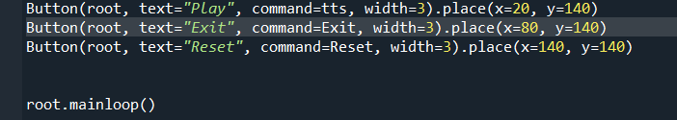

These are buttons and its own command. Mainloop used so the application doesn’t close in 1 sec after executing the codes

1. Modules.py

Purpose : to house the essential modules

Components shown below:

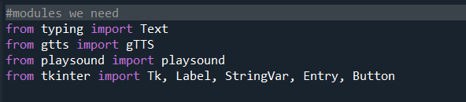

Used to house all the modules, typing import Text means to read what inside the box

,gtts to import all the module relevant from Google Text to Speech , Playsound used for playing the TTS output without rely on media player installed on PC , Tkinter used for desiging UI for the python.

**HOW TO USE**

Its pretty simple using my python TTS

1. Execute the code
2. Put anything text on text box
3. Press “play button to play the voice

Note: Apparently my application had some stutter/lag/delay while playing for the first time, you should wait a bit so my app can play the text